NAME: **Daniel Carpenter**

STUDENT ID: **113009743**

GRADED HOMEWORK NUMBER: **1**

COURSE: CS/DSA 4513 - DATABASE MANAGEMENT

SECTION: ONLINE

SEMESTER: FALL 2021

INSTRUCTOR: DR. LE GRUENWALD

SCORE:

**Problem 1.1**

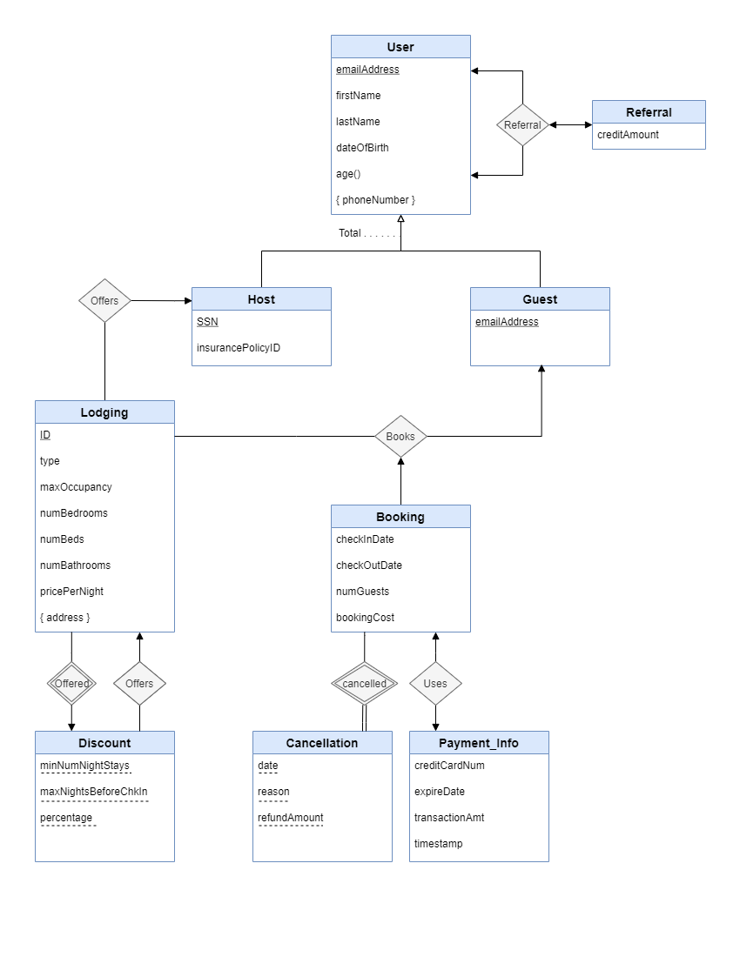

**Problem 1.2**

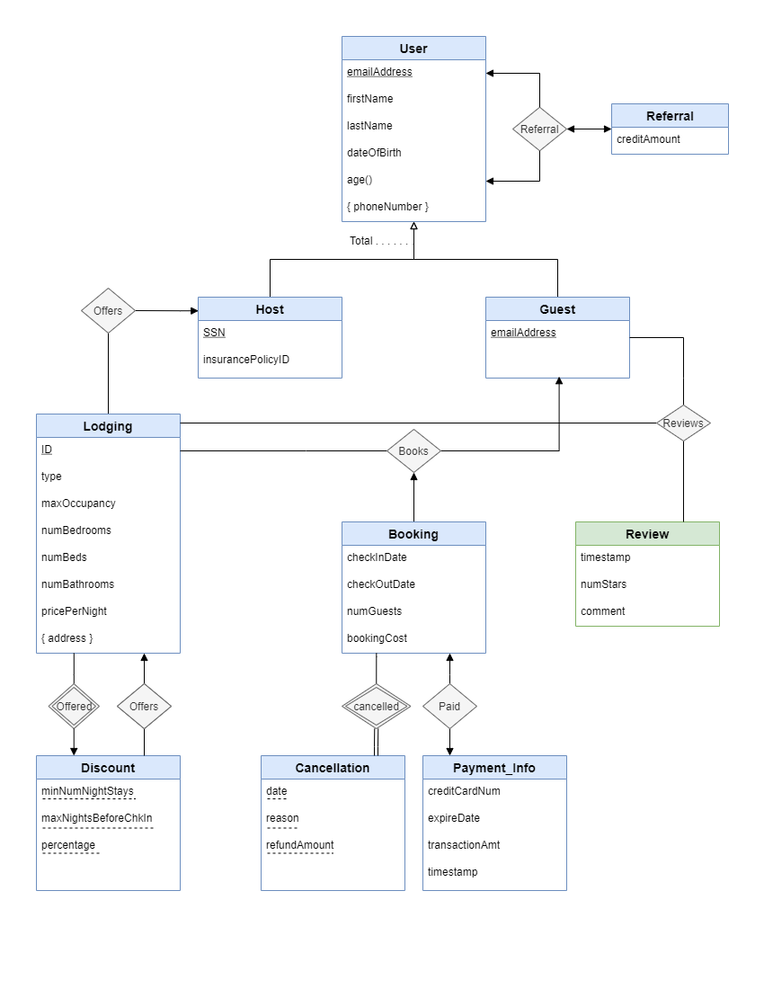

**Problem 1.3**

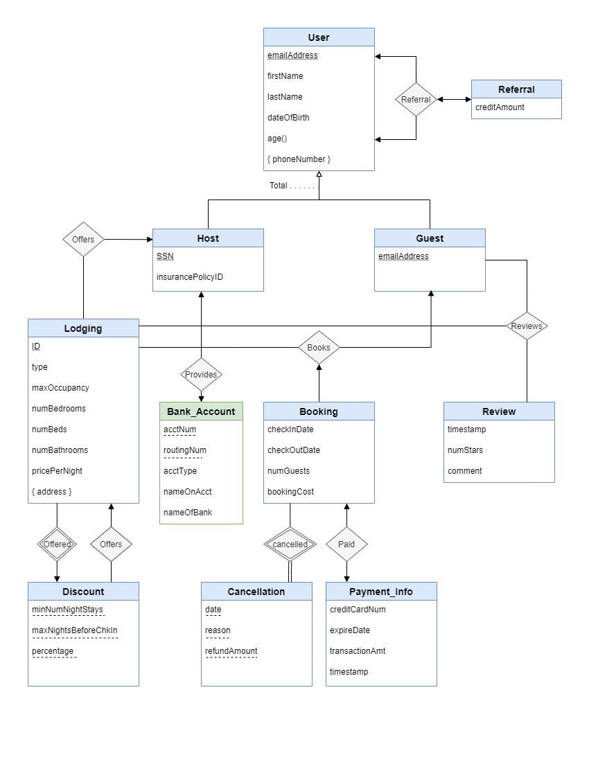

**Problem 1.4**

